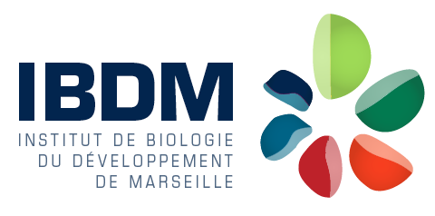

Engineer in optical imaging for biology

France Bio-Imaging Marseille, Institut de Biologie du Développement de Marseille, Campus de Luminy, Marseille, France

An engineer position to develop instruments in optical microscopy and to assist users in the acquisition/analysis of data is available at the France Bio-Imaging Marseille infrastructure, France. We are seeking a highly motivated candidate with a master degree (min.) and a solid experience in optical microscopy and imaging, including optical instrumentation and image analysis. Knowledge in biology is desirable. The initial appointment will be made for 1 year, with a possible extension.

The responsibilities of the successful candidate will include:
- Train users (staff scientists, technicians, students) on advanced microscopy setups (confocal, spinning-disk, multiphoton microscopes, STED and light sheet) for biological imaging
- Assist users in the choice and use of methods adapted to their needs
- Test and optimize advanced microscopy setups on a regular basis
- Develop /adapt a high-resolution imaging setup and assist users in implementing adapted protocols (labelling, acquisition and data analysis)

More information about the institute can be found at http://www.ibdm.univ-mrs.fr/

A letter of motivation, a CV and the names of two referees should be sent to Pierre-François Lenne (pierre-francois.lenne@univ-amu.fr) and Cédric Matthews (cedric.matthews@univ-amu.fr).

